



Sample Process Document

**(Process Document SamdhanV2 Geographical Structure**)

Version2.0

Date : 19 Sep 2019

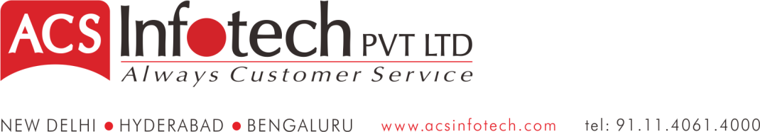

TABLE OF CONTENTS

1 Introduction 1

2 Flowchart 4

3 Process of Geographical Structure 4

4 Validations 7

5 Key Reports 7

**Introduction**

**Geographic** organisation is an organisation **structure** where company hierarchy is divided on the basis of **geographic** location in which company operates which is headed by a centralised head office. This kind of organisational **structure** serves distinct needs of various different groups within the country.

**Geographic departmentalization** - Grouping activities on the basis of territory. If an organization's customers are geographically dispersed, it can group jobs based on **geography**. ... Process **departmentalization** - Grouping activities on the basis of product or service or customer flow.

## The Benefits

Bringing together employees from different functional specialties allows a geographical division to respond more quickly and efficiently to the division's needs than would be possible if some operations had to be met from a remote, centralized location. Being together, specialties within the division also find it easier to coordinate with one another to meet the unique challenges of their geographical location. The geographical grouping focuses all worker efforts solely on the objectives of their own division, increasing results. This structural approach also demands leadership from managers, who gain valuable experience that expands the company's executive talent pool. Managers who have operated a geographical division know what it takes to effectively lead at the top of a chain of command.

## When to Use It

Divisions are best able to serve the needs and desires of distinct groups. In the case of geographical divisions, differing cultures, rules, languages and customer preferences between areas make establishing geographical divisions a good idea. Additionally, logistical concerns can give rise to geographical divisions. When it is more logistically sound to ship locally, use local resources and hire local people, a geographical structure may be the best choice.

**Flow Chart**

State1

Distirict3

Distirict2

Distirict1

Tehsil2

Tehsil1

Gram Panchayat2

Gram Panchayat1

Villege1

Villege2

Villege3

Villege2

Villege1

Validations

1. **Passing Voucher Entry against Account linked with BUDGET**

In case Budget Module is activated, the system will perform following validations:

* While passing Voucher entry against an Account / Subaccount which is linked with a Budget, the system will check the Budget vs Actual value against the defined budget linked to the account.
* In case the Budgeted figure is already achieved, then system will check setup. Incase setup defined doesn’t allow the value to be crossed, then system will throw alert and will not save Voucher.
* Incase location wise budget setup has been defined and further user has not defined the budget values for the selected period, the system won’t allow the voucher to be saved.

1. **Uploads**

All the uploads from where the Vouchers are posted, validation on Budget values will be done as referred in point no 5.

1. **Budget-To-Actual Report.** This **report** shows the difference between your budgeted Values and **actual** Values achieved against a selected Budget. Budget v/s Actual Report can be generated on following parameters:
   1. **BUDGET –** Selective / All
   2. **LOCATION –** Selective / All
   3. **PERIOD –** Period for which Budget v/s Actual variation needs to be generated. Period can’t be specified across Financial Year.
   4. **SUMMARY or DETAIL**
   5. **Grouping** –
      1. Budget wise – Location Wise
      2. Location wise – Budget wise
   6. **Output –** 
      1. Screen – Report data will be displayed on the screen in Grid format. By default data will be displayed in Summary format. User can drill down to Voucher Level
      2. Excel – Based on parameters selected, data will be displayed in Excel.